Name: | Vasundhara Singh
UID no.: | 2021700062
Experiment No. | 4
Class: | SE CSE(DS)
Batch: | D-4
Date of Experiment: | 06/03/2023

AIM: | Implement Dynamic Programming in finding Longest Common Subsequence
PROBLEM STATEMENT: | Find the longest common subsequence between two strings input by user through dynamic programming technique.
THEORY: | Dynamic Programming is mainly an optimization over plain recursion. Wherever we see a recursive solution that has repeated calls for same inputs, we can optimize it using Dynamic Programming. The idea is to simply store the results of subproblems, so that we do not have to re-compute them when needed later. This simple optimization reduces time complexities from exponential to polynomial.  The longest common subsequence (LCS) is defined as the longest subsequence that is common to all the given sequences, provided that the elements of the subsequence are not required to occupy consecutive positions within the original sequences.  If S1 and S2 are the two given sequences then, Z is the common subsequence of S1 and S2 if Z is a subsequence of both S1 and S2. Furthermore, Z must be a strictly increasing sequence of the indices of both S1 and S2.  In a strictly increasing sequence, the indices of the elements chosen from the original sequences must be in ascending order in Z.
PROGRAM: | #include <stdio.h>  #include <string.h>  int i, j, m, n, LCS_table[20][20];  char S1[20], S2[20];  void print()  {  printf("\t\t\t");  for (int k = 0; k <= n; k++)  printf("|\t%c\t", S2[k]);  printf("\n\t");  for (int k = 0; k <= n; k++)  printf("|\t%d\t", LCS_table[k][0]);  printf("|\n");  for (int k = 1; k <= m; k++)  {  printf("%c\t|\t", S1[k - 1]);  for (int l = 0; l <= n; l++)  {  printf("%d\t|\t", LCS_table[k][l]);  }  printf("\n");  }  }  void lcs()  {  m = strlen(S1);  n = strlen(S2);  // Filling 0's in the matrix  for (i = 0; i <= m; i++)  LCS_table[i][0] = 0;  for (i = 0; i <= n; i++)  LCS_table[0][i] = 0;  // Building the matrix in bottom-up way  for (i = 1; i <= m; i++)  {  for (j = 1; j <= n; j++)  {  if (S1[i - 1] == S2[j - 1])  {  LCS_table[i][j] = LCS_table[i - 1][j - 1] + 1;  }  else if (LCS_table[i - 1][j] >= LCS_table[i][j - 1])  {  LCS_table[i][j] = LCS_table[i - 1][j];  }  else  {  LCS_table[i][j] = LCS_table[i][j - 1];  }  }  }  int index = LCS_table[m][n];  char lcs[index + 1];  lcs[index] = '\0';  print();  int i = m, j = n;  while (i > 0 && j > 0)  {  if (S1[i - 1] == S2[j - 1])  {  lcs[index - 1] = S1[i - 1];  i--;  j--;  index--;  }  else if (LCS_table[i - 1][j] > LCS_table[i][j - 1])  i--;  else  j--;  }  // Printing the sub sequences  printf("\n\nS1 : %s \nS2 : %s \n", S1, S2);  printf("\nLongest Common Subsequence: %s", lcs);  }  int main()  {  printf("Enter the first string: ");  scanf("%s", S1);  printf("Enter the second string: ");  scanf("%s", S2);  lcs();  printf("\n");  }
RESULT: | 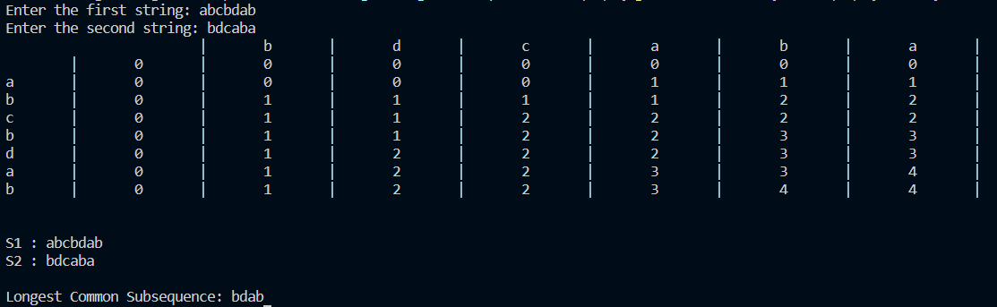
SOLUTION: | 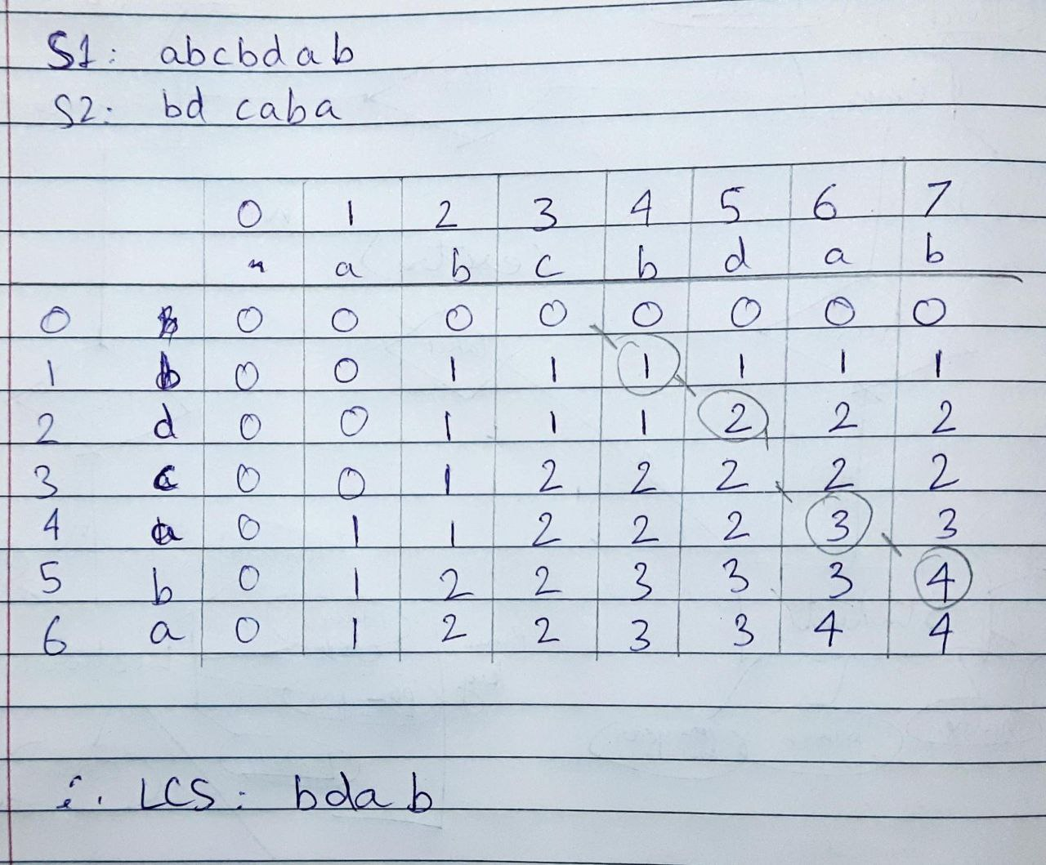
CONCLUSION: | Implemented dynamic programming for finding Longest Common Subsequence between two strings.

